Posted 01/07/2015 at 2:07 pm by JAV
\

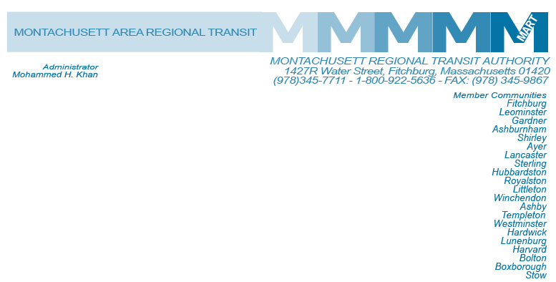

MART Maintenance Facility
1427R Water Street
Fitchburg, MA 01420

MEETING OF THE MART Finance/Executive Compensation COmmittee
Tuesday, January 13, 2015
10:00 A.M.

Agenda
- Status of Hiring for Controller Position
- Review Revenue and Expenditures 5 Months
- Revised FY2015 Budget
- Mayor Hawke’s Response to Michael Lambert, MassDOT, December 15, 2014 Letter
- Proposed Fare Increase/Public Hearing
- General Comments
- Adjournment
C: City and Town Clerks: Please post this notice pursuant to MA General Laws Chapter 30A,
Sections 18-25.

